Walnut High School Four Year Plan
Class of 2027
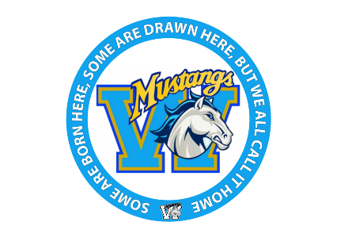
Name: | ID: | GLC:

Post- Secondary Goal: UC CSU Private University Community College/Vocational

Career Interests:
1. | 2.
9th Grade Pathways (Circle if applicable): Academic Design Program Pre-IB

9th Grade |  | 10th Grade
Summer before 9th: |  | Summer before 10th:
English: |  | English:
Math: |  | Math:
Science or Elective: |  | Science:
Social Science: |  | Elective:
For. Lang. / Elective: |  | For. Lang. / Elective:
PE/Athletics |  | PE/Athletics
10th 11th 12th Grade Pathways (Circle if applicable): IBDP IBCP PLTW ADP ROP

11th Grade |  | 12th Grade
Summer before 11th: |  | Summer before 12th:
English: |  | English:
Math: |  | Math:
US History: |  | Civics/Economics:
For. Lang. / Elective: |  | For. Lang./Elective:
PE or Elective: |  | Elective:
Elective: |  | Elective
7th Class – IB/IBCP only: |  | 7th Class – IB/IBCP only:

To review course offerings & Pathways, log onto www.walnuths.net and click on the academics tab.

